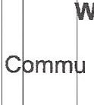RESOLUTION 19-17

A RES LUTION OF THE TOWN COUNCIL OF THE TOWN OF CENTURY, FLORIDA,
p av DING FOR THE CREATION OF THE CENTURY COMMUNITY
R DE ELOPMENT AGENCY; PROVIDING FOR THE EXERCISE OF POWERS OF S ID GENCY; AND PROVIDING AN EFFECTIVE DATE.

HEREAS, pursuant to Part 111, Chapter 163, Florida Statutes, entitled nity Redevelopment, the Century Town Council adopted Resolution No.
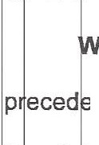
1 -17 n September 11, 2017; and,

HEREAS, the Town of Century, Florida, has complied with the conditions nt to the creation of a community redevelopment agency by adopting
R solu ion No. 18-17, making a finding of necessity for the rehabilitation, c nse ation or redevelopment, or a combination thereof, of blighted areas within th in orporated area of the Town and determining that a certain area within the T wn hall be a community redevelopment area.

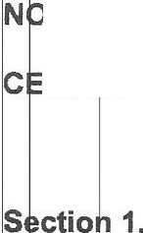
W HEREFORE, BE IT RESOLVED BY THE TOWN COUNCIL OF THE TOWN OF NT RY, FLORIDA:

Definitions. The definition of terms as provided in Section 163,340 , Fl rida Statutes, are hereby adopted by reference whenever used or referred to in this R solu ion.

- 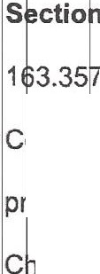Creation of Community Redevelopment Agency. Pursuant to Section

, Florida Statutes, the Century Town Council hereby declares itself to be the C mm nity Redevelopment Agency in the Town of Century. All rights, powers-, duties, p ivile es and immunities vested in a community redevelopment agency by Part Ill , apt r 163, Florida Statutes, are hereby vested in the Town Council of the Town of
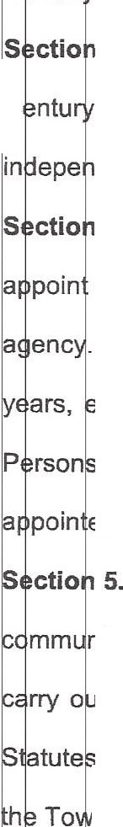
C ntu , Florida, subject to all responsibilities and liabilities imposed or incurred.

- Members of the Community Redevelopment Agency. The members of the C Town Council shall constitute the head of a legal entity, separate, distinct and
dent from the Century Town Council.

- Additional members. The Century Town Council may, at its option, two additional persons to act as members of the community redevelopment
. The terms of office of any additional members appointed shall be for four xcept that the first person appointed shall initially serve a term of two years. appointed under this section are subject to all provisions of this part relating to
pain ed members of a community redevelopment agency.

Powers. The community redevelopment powers assigned to the mm nity redevelopment agency include all the powers necessary or convenient to t and effectuate the purposes and provisions of Part 111, Chapter 163, Florida
, except the following powers which will continue to vest in the Town Council of n of Century:
The power to determine an area to be a slum or blighted area, or combination thereof; to designate such area as appropriate for community redevelopment; and to hold any public hearings required with respect hereto.

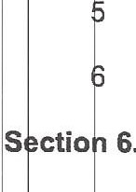) The power to grant final approval to community redevelopment plans and modifications thereof.
) The power to authorize the issuance of revenue bonds as set forth in- art rn,
Chapter 163.385, Florida Statutes.

The power to approve the acquisition, demolition, removal or disposal of property as provided in Part Ill, Chapter 163.370(4), Florida Statutes and the power to assume the responsibility to bear loss as provided in Part Ill, Chapter 163.370(4), Florida Statutes.
The power to approve the development of community policing innovations.

) The power of eminent domain.

Effective Date. This Resolution shall take effect immediately upon a opti n by the Century Town Council.

- \' t fl t 1 :, 1,t ,
SS OJAN' D-ADOPTED THIS 11th DAY OF SEPTEMBER, 2017.
'j . . .•····· ...

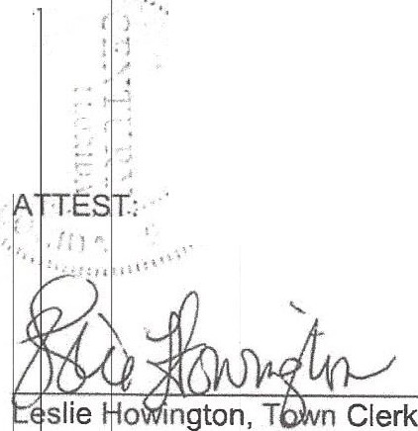
/ .··
- ( j .-·
I;; :·
- ...
,,_ .
. :: - { :
:.:. C'...' ·:
- - .'.) . .
  - ·'.,,.' .,,,· .
- .. ,. ' .
•• ,·_1
: ',/,i
.
. . .
:
.
_: /;1
.··......'...
..•..'.

TOWN OF CENTURY, a municipality Chartered in the State of Florida, by its TOWN COUNCIL

. fl-

Ann Brooks, President

lfi----

Heri? Hawkins, Mayor

