RESOLUTION 18-17

A RESOLUTION OF THE CENTURY TOWN COUNCIL, PURSUANT TO PART Ill, CHAPTER 163, FLORIDA STATUTES, RELATING TO COMMUNITY REDEVELOPMENT; FINDING THAT THERE IS A BLIGHTED AREA WITHIN THE TOWN OF CENTURY; MAKING CERTAIN FINDINGS AND DETERMINATIONS; FINDING THAT THERE IS A NEED TO DESIGNATE A COMMUNITY REDEVELOPMENT AREA; FINDING A NEED FOR CREATING A COMMUNITY REDEVELOPMENT AGENCY; PROVIDING FOR SEVERABILITY; AND PROVIDING FOR AN EFFECTIVE DATE.

NOW, THEREFORE BE IT RESOLVED BY THE TOWN COUNCIL OF THE TOWN OF CENTURY, FLORIDA THAT:

Section 1. Authority. This resolution is adopted pursuant to the provisions of Part Ill, Chapter 163, Florida Statutes, known as the "Community Redevelopment Act of 1969."
Section 2. Definitions. The definition of the terms as provided in Section 163.340, Florida Statutes, are hereby adopted by reference whenever used or referred to in the Resolution. In addition, the term, "Community Redevelopment Area" when used in this Resolution means the area within the boundaries of the Town of Century, Florida, as
outlined in the map and legal description attached hereto and incorporated herein as Exhibit A.
Section 3. Notice. The Century Town Council hereby finds that all public notices and notices to taxing authorities were timely and properly published and mailed pursuant to Section 163.346, Florida Statutes.

Section 4. Findings and Determinations. determines as follows:
The Century Town Council finds and

- The Century Town Council finds that the area referred to as the Community

Redevelopment Area is a blighted area, as determined by the Findings of Necessity attached as Exhibit B, which substantially impairs the sound growth of the Town, and is a threat to the public health, safety, morals and welfare of the residents of the Town. The existence of blight further creates an economic and social liability by hindering development discouraging private investment, reducing employment opportunities, retarding the construction and improvement of housing accommodations, causing an excessive proportion of expenditures for crime prevention and other forms of public services and depressing the tax base.
- The Century Town Council finds that a combination of rehabilitation, conservation and redevelopment of the area identified as the Community Redevelopment Area is necessary in the interest of the public health, safety, morals and welfare of the residents of the Town in order to eliminate, remedy and prevent conditions of blight.
- The Century Town Council finds and determines that there exists a need for the Community Redevelopment Agency to carry out redevelopment purposes pursuant to Part Ill, Chapter 163, Florida Statutes, in the Community Redevelopment Area.

- The Century Town Council finds and determines that the area described in Exhibit A and entitled Community Redevelopment Area is appropriate for redevelopment projects and is hereby designated a Community Redevelopment Area.
Section 5. Effective Date. This Resolution shall take effect immediately upon adoption by the Century Town Council.

. , . P., [j ADOPTED THIS 11th DAY OF SEPTEMBER, 2017.

,,, : '

: i.,.....
.'I.' . .THIS IS THE TOWN SEAL
1..JO •
·.

•:,. . . .
...₋.- .
r ;
':.' ·l
-• I •:
,-:. I 1
;:· , ··'

I

) - ; .
·, ... ·;.
•• \ ,i

....-,._,' .:--

TOWN OF CENTURY, a municipality Chartered in the State of Florida, by its TOWN COUNCIL

' :.- t j •• • i
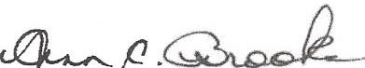', ·.,.ATTEST:' ' .·.-: ..

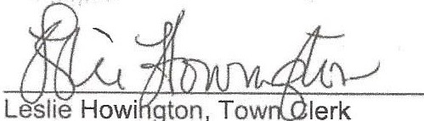
Ann Brooks, President

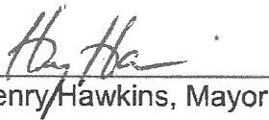

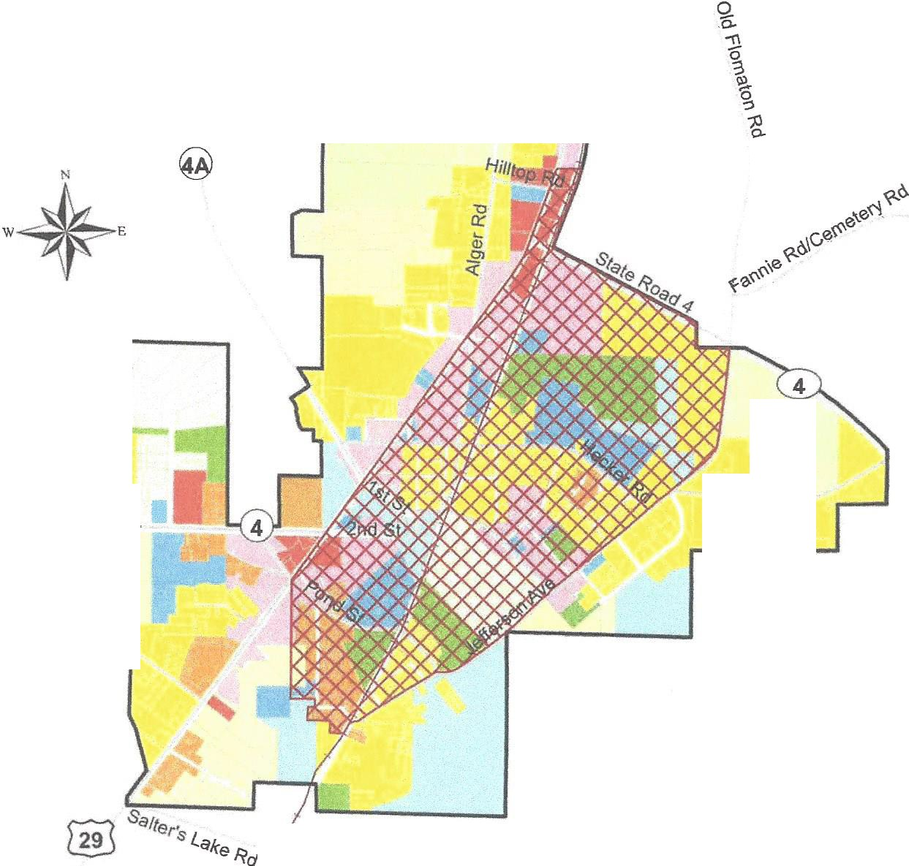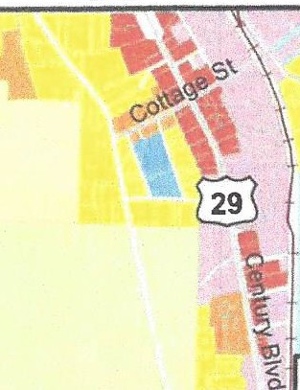Alabama Florida

\f'J
EXHIBIT A - CRA BOUNDARY MAP
- eRd
state un C

...J

TOWN OF CENTURY, FLORIDA

FUTURE LAND USE MAP 2025

ADOPTED MARCH 19, 2012
ORDINANCE #06-11

s

"E_,
[l:'.
11l=
a:
Q)--
I

Industrial Blvd

County Road·4-

McCall Rd
_Freedom Rd

LEGEND
0 0.25 0.5 1
Miles

- Conservation 1111 HDR (6-10 du/ac) CJ Town Limits
_ Agriculture 1111 Parks & Recreation -+--+- CSX Railroad Environmentally Sensitive 1111 Public/Institutional l'v'V1 Proposed CRA
510Acres
This map was compiled from Escambia County GIS data and does not reflect an actual survey. The Town of Century
does not assume responsibility for errors
or omissions contained hereon.

Rural Residential (1 du/ac) Ill Mixed Use

LDR (1-4 du/ac)
Ill MDR (4•6 du/ac)
- Commercial
:_-_J Industrial

W"'1 A¢d •

Regional
Planning

May 9, 2017 Centu ryFLUM _ CRA20 17.mxd

Councll

'

EXHIBIT A - CRA LEGAL DESCRIPTION

FABRE. ENGINEERING 8.. SURVEYING - - - - - - - -
£NQN££RS ♦ PlANNERS ♦ SURVEYORS

BEGIN AT THE INTERSECTION OF THE EAST RIGHT OF WAY LINE OF CSX RAILROAD AND THE NORTH RIGHT OF WAY LINE OF STATE ROAD 4 (100' R/W) IN SECTION 5, TOWNSHIP 5 NORTH, RANGE 30 WEST, ESCAMBIA COUNTY, FLORIDA; THENCE PROCEED SOUTHEASTERLY ALONG SAID NORTH LINE TO THE INTERSECTION OF THE WEST LINE OF SECTION 4, TOWNSHIP 5 NORTH, RANGE 30 WEST, ESCAMBIA COUNTY, FLORIDA; THENCE DEPARTING THE AFORESAID NORTH LINE PROCEED SOUTHERLY ALONG SAID WEST LINE OF SECTION 4, TO THE INTERSECTION OF THE SOUTH RIGHT OF WAY LINE OF STATE ROAD 4 (100' R/W); THENCE DEPARTING SAID SOUTH RIGHT OF WAY LINE, PROCEED SOUTHERLY ALONG THE AFORESAID WEST LINE TO THE SOUTHWEST CORNER OF THE NORTH WEST ¼ OF SECTION 4, TOWNSHIP 5 NORTH, RANGE 30 WEST; THENCE PROCEED EASTERLY ALONG THE SOUTH LINE OF SAID NORTHWEST ¼ TO THE INTERSECTION OF THE WEST RIGHT OF WAY LINE OF JEFFERSON AVENUE; (R/W VARIES) THENCE PROCEED SOUTHWESTERLY ALONG THE SAID WEST RIGHT OF WAY LINE TO THE CENTERLINE INTERSECTION OF CSX RAILROAD (100' R/W); THENCE PROCEED SOUTHERLY ALONG SAID CENTERLINE TO THE INTERSECTION OF THE EXTENTION OF THE SOUTH LINE OF OR BOOK 6498, PAGE 980; THENCE PROCEED WESTERLY ALONG THE SOUTH LINE TO THE SOUTHWEST CORNER AS DESCRIBED IN OR BOOK 6498, PAGE 980; THENCE PROCEED NORTH TO THE NORTH LINE OF THE SOUTHWEST 1/4 OF SECTION 8, TOWNSHIP 5 NORTH, RANGE 30 WEST, ESCAMBIA COUNTY, FLORIDA; THENCE PROCEED WEST ALONG SAID NORTH LINE TO THE INTERSECTION OF THE WEST LINE OF THAT DESCRIBED IN OR BOOK 5134, PAGE 1078; THENCE PROCEED NORTHERLY ALONG SAID WEST LINE TO THE NORTHWEST CORNER OF THAT DESCRIBED IN OR BOOK 134, PAGE 1078; THENCE PROCEED EASTERLY TO THE NORTHEAST CORNER OF THAT DESCRIBED IN OR BOOK
6003, PAGE 1590 AND THE WEST RIGHT OF WAY OF JEFFERSON AVENUE (R/W VARIES); THENCE PROCEED NORTHERLY ALONG SAID WEST RIGHT OF WAY LINE TO THE SOUTH EAST CORNER AS THAT DESCRIBED IN OR BOOK 483, PAGE 956; THENCE PROCEED WESTERLY ALONG THE SOUTH LINE AS THAT DESCRIBED IN OR BOOK 483, PAGE 956, TO THE INTERSECTION OF THE WEST LINE OF THAT DESCRIBED IN OR BOOK 4517, PAGE 13; THENCE PROCEED NORTH ALONG THE WESTERLY EXTENTION OF THAT DESCRIBED IN OR BOOK 4517, PAGE 13 TO THE INTERSECTION OF THE WEST RIGHT OF WAY LINE OF U.S. HIGHWAY 29, (R/W VARIES); THENCE PROCEED NORTHERLY ALONG SAID WEST RIGHT OF WAY LINE OF U.S. HIGHWAY 29 TO THE SOUTHEAST CORNER OF THAT DESCRIBED IN OR BOOK 6729, PAGE 282, THENCE DEPARTING THE AFORESAID WEST RIGHT OF WAY LINE PROCEED EAST TO THE NORTHWEST CORNER OF THAT DESCRIBED IN OR BOOK 6144, PAGE 1370; THENCE DEPARTING SAID EAST RIGHT OF WAY LINE PROCEED EASTERLY TO THE INTERSECTION OF THE NORTH LINE OF THAT DESCRIBED IN OR BOOK 6144, PAGE 1370 AND THE EAST RIGHT OF WAY LINE OF CSX RAILROAD (100' R/W); THENCE PROCEED SOUTHERLY ALONG SAID EASTERN RIGHT OF WAY LINE TO THE NORTH RIGHT OF WAY LINE OF STATE ROAD 4 ANO THE POINT OF BEGINNING.
LYING IN AND BEING A PART OF SECTIONS 5, & 8, TOWNSHIP 5 NORTH, RANGE 30 WEST, ESCAMBIA COUNTY, FLORIDA, CONTAINING 510 ACRES MORE OR LESS.

I 19 GRfGORY SQUAAE POl5ACOlA, fl..ORJM 32502 ♦ lU!PHONE: (850) 433-6438
21530PROFLSSIONALORM SUITlB- 105 ROBDU'SIWL. 36567 ♦ TEUPHONE(Z51)94S-1937

EXHIBITB

Findings of Necessity
Town of Century Community Redevelopment Area

Introduction

As directed by the Century Town Council, this report is prepared to support the proposed creation of a Century Community Redevelopment Area. A map depicting the proposed redevelopment area and boundary description for the proposed area are presented as Exhibit A. Date obtained from the U.S. Census Bureau, 2011-2015 American Community Survey 5-Year Estimates and field surveys were used to formulate these findings. The following data and analysis support the legislative finding that conditions in the proposed redevelopment area meet the criteria of blight as described in Florida Statute 163.340(8).

Findings

A "blighted area" is an area experiencing economic distress, endangerment to life or property due to the presence of a large number of deteriorated structures. The proposed area exhibits conditions of blight as defined in Florida Statutes to include the fotJowing:

Finding I: Predominance of defective or inadequate street layout, parking facilities, roadways, bridges, or public transportation facilities:

The proposed redevelopment area lacks public infrastructure to include adequate street layout, paved roads and stonnwater management systems. Inadequate street layout, lack of paved roads and stormwater management systems, appears to contribute to faulty lot layouts and usefulness of the property. Lack of adequate public infrastructure hinders reinvestment and redevelopment opportunities. The faulty lot layouts, lack of accessibility or usefulness of property in the proposed redevelopment area supports the need for redevelopment.

Finding 2: Deterioration of site and other improvements:

Based upon windshield surveys conducted during the month of June 2017, there is a predominance of deteriorated or dilapidated housing in the proposed area. Single family residents were scored based upon a point system ranging from 1, Excellent Condition to 4, Dilapidated Condition. The housing conditions windshield survey results found 119 or 47% of the single family houses in the area fall in the categories of poor or dilapidated condition which means they require some form of rehabilitation or demolition/reconstruction. Seventy-one (71) housing units or 28% were found to be in good condition. However, these housing units show need for repair or rehabilitation as indicated by structural or roof conditions and lack of energy
related improvements. Sixty-seven or 26% of housing units were found to be in excellent condition.

It should be noted that almost one-half or 49.5% of the Town's housing stock was constructed prior to 1960. Over 160 or 20.7% of the homes in Century are 50 years or older. The majority of the houses in the proposed area were constructed prior to 1960. In addition, there are forty­ eight (48) mobile homes located within the proposed area. Mobile homes comprise 19% of the total housing units within the proposed redevelopment area.

Due to the age of the majority of the houses in the proposed area, it would make sense that the houses are in need for repair or rehabilitation to include energy related improvements. The median value of owner-occupied housing in the Town of Century is $40,000 compared to the County median housing value of $81,700. More than half or approximately 59.5% of total housing units are valued at less than $50,000. Overall housing conditions and values support the need for redevelopment in the area.

The average median household income in the area is $24,583 compared to Escambia County's median household income of$46,001.

Lack of complete and accurate legal descriptions, lack of title to the property and unpaid ad valorem property taxes also are factors which constitutes an economic and social liability imposing onerous burdens which decrease the tax base and reduce tax revenues.

Summary

Based upon the findings presented, the proposed redevelopment area exhibits conditions of blight as defmed by Florida Statutes. The proposed area would benefit from redevelopment programs and projects. A combination of rehabilitation, conservation and redevelopment of the proposed area will support the elimination, prevention and remedy of the conditions of blight.

